Calculus Based Physics I: LAB

PHYS 2110 WA

Date: July 15, 2023

Isaac Abella

Lab 10: The Internal Resistance of a Battery

Groups:  
Isaac Abella

**Objective:**

To understand the effect of the internal resistance of a battery.

**Equipment:**

A computer with internet connection, a calculator, paper, pencil, calculator (ti-84 plus CE/ti-30sx II)

**Theory:**

The ideal voltage source is when a voltage source can maintain a constant voltage, regardless of the current that it has to supply. For real voltage sources such as batteries, this is not the case. When the current from the battery increases, then there is a voltage drop across all terminals connected. This causes the voltage to drop from the **nominal voltage.** This is because the battery has **an internal resistance, r,** that becomes a consumer in series with the external resistances/loads.

One way to visualize this internal resistance in the battery source is to think of how car battery work when different appliances are turned on. The battery when not in use has a stable voltage that can be called the nominal voltage, and when turning on appliances such as headlights or cabin lights, the voltage will drop.

When an **external resistance R (the load or other consumers other than the battery)** is connected to a battery of **nominal voltage V** and **internal resistance r.** Then you can write Ohm’s Law as:   
  
 **Vnom = RI + rI, or Vnom = (R+r)I, or I = Vnom/(R+r)**

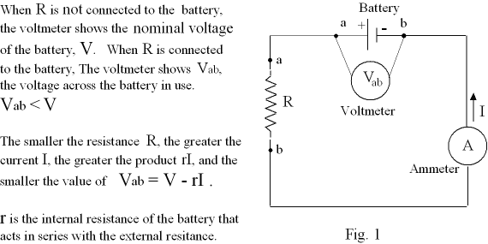

**Procedure:**

After starting the lab, a circuit was constructed following the lab manual’s instructions. When configuring the resistors, the resistance R at the top side of the circuit was considered the external load. Then the battery’s internal resistance, external resistance, and voltage were changed to follow the current case in the data table.

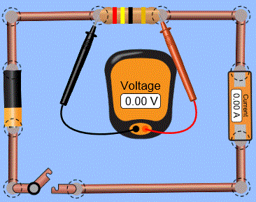

Once the voltage and the resistances of the internal and external resistances were configured. They were then used to calculate the ideal voltage, the real voltage, and then the percent decrease.

The percent decrease formula was given in the lab manual as:  
  
 **% Decrease: {(Ideal Current – Real Current) / Ideal Current} * 100**

**Data:**

**Table 1:**

|  |  |  |  |  |  |  |  |
| --- | --- | --- | --- | --- | --- | --- | --- |
| **Trial** | **Vnominal**  **(Volts)** | **Internal**  **Resistance**  **r (Ω)** | **External Resistance**  **R (Ω)** | **Actual**  **Voltage Across load.** | **Expected**  **(Ideal Current)**  **Vnom./R** | **Real Current**  **Vnom/(R+r)** | **% Decrease in Current** |
| **1** | **12.0** | **1.0** | **120.0** | **11.90** | **0.1** | **0.099** | **1** |
| **1** | **12.0** | **1.0** | **70.0** | **11.83** | **0.171** | **0.169** | **1.169** |
| **3** | **12.0** | **1.0** | **30.0** | **11.61** | **0.4** | **.387** | **3.25** |
| **4** | **12.0** | **1.0** | **15.0** | **11.25** | **0.8** | **0.75** | **6.67** |
| **5** | **12.0** | **1.0** | **5.0** | **10.0** | **2.4** | **2.00** | **16.7** |
|  |  |  |  |  |  |  |  |
| **1** | **12.0** | **2.0** | **120** | **11.80** | **0.1** | **0.0984** | **1.6** |
| **2** | **12.0** | **2.0** | **70.0** | **11.67** | **.171** | **0.167** | **2.33** |
| **3** | **12.0** | **2.0** | **30.0** | **11.25** | **0.4** | **0.375** | **6.25** |
| **4** | **12.0** | **2.0** | **15.0** | **10.59** | **0.8** | **0.706** | **0.094** |
| **5** | **12.0** | **2.0** | **5.0** | **8.57** | **2.4** | **1.71** | **28.75** |
|  |  |  |  |  |  |  |  |
| **1** | **24.0** | **1.0** | **120** | **23.80** | **0.2** | **0.198** | **1** |
| **2** | **24.0** | **1.0** | **100** | **23.76** | **0.24** | **0.238** | **0.833** |
| **3** | **24.0** | **1.0** | **60.0** | **23.61** | **0.4** | **0.393** | **1.75** |
| **4** | **24.0** | **1.0** | **20.0** | **22.86** | **1.2** | **1.14** | **5** |
| **5** | **24.0** | **1.0** | **8.0** | **21.33** | **3** | **2.67** | **11** |
|  |  |  |  |  |  |  |  |
| **1** | **24.0** | **3.0** | **120** | **23.41** | **0.2** | **0.195** | **2.5** |
| **2** | **24.0** | **3.0** | **100** | **23.30** | **0.24** | **0.233** | **2.91** |
| **3** | **24.0** | **3.0** | **60.0** | **22.86** | **0.4** | **0.381** | **4.75** |
| **4** | **24.0** | **3.0** | **20.0** | **20.87** | **1.2** | **1.04** | **13.3** |
| **5** | **24.0** | **3.0** | **8.0** | **17.45** | **3** | **2.18** | **27.3** |

**Calculations:**

The calculations for values of Ideal Current, Real Current, and Percent Decrease were all calculated with given equations by the lab manual mentioned in the theory and procedure category.

*Sample Calculation:*

Case 1, Trail 1: Vnom = 12.0 Volts, 1 Ohm r, 120 Ohm R

* Ideal Current = Vnom/R = 12.0 / 120 = 0.1 A
* Real Current = Vnom/(R+r) = 12.0 / (120 + 1) = 0.099 A
* Percent Decrease = {(Ideal Current – Real Current) / Ideal Current} * 100 = (0.1 – 0.099)/(0.1) = 0.01 * 100 = 1%

**Conclusion:**

The objective of this experiment was to understand the effect of the internal resistance of a battery. By considering the resistance of the battery in series with another resistor in a circuit, there is a difference in current that can be noticed as the noticed significantly more if the external resistance load is lower.

**Discussion:**

When measuring the ideal and real current of cases where the external resistance **R** was far greater than the internal resistance **r,** then the difference in ideal and real currents was very low, usually within a percent of each other. But when the external resistances were low, such as resistance of 8 ohms compared to a 3-ohm internal resistance like in case 4 trial 5, then the percent error can be high.

When solving for Case 4, Trial 5, the percent decrease between the ideal and real currents was 27%. And this trend of lower external resistances in series with an internal resistance leading to a higher difference in real and ideal voltages is present in all 4 cases and their trails.